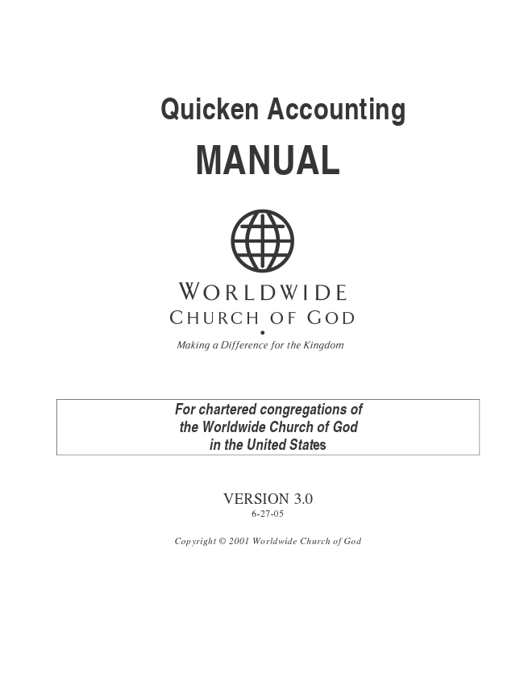
Quicken Accounting
MANUAL
For chartered congregations of the Worldwide Church of God in the United States
VERSION 3.0 6-27-05
Copyright © 2001 Worldwide Church of God
Change Log
6/27/05
- Updated Quarterly and Annual screen shots in section 14.3 and 14.4 so that they were
clearer to understand.
TABLE OF CONTENTS
10.0 QUICKEN: SOFTWARE FOR LOCAL ACCOUNTING RECORDS............................................... 1 11.0 QUICKEN: INSTALLATION AND FIRST-TIME SETUP............................................................. 3 11.1 Installing Quicken 2002.............................................................................................................. 3 11.2 Installing Quicken 2003.............................................................................................................. 3 11.3 Installing Quicken 2004.............................................................................................................. 3 11.4 Setting Up Bank Accounts......................................................................................................... 4 11.5 Budget Category Setup.............................................................................................................. 5 11.5.1 Typical Income Account Categories.................................................................................... 5 11.5.2 Typical Expense Account Categories.................................................................................. 6 11.6 Report Name Initialization.......................................................................................................... 6 11.7 Deleting Default Shell Reports................................................................................................... 9 11.8 Password Protection................................................................................................................ 10 12.0 QUICKEN: ENTERING TRANSACTIONS ............................................................................ 11 12.1 Check Register Instructions..................................................................................................... 12 12.2 Electronic Fund Transfer (EFT) Transactions........................................................................... 13 12.3 Special Event Income And Expense Transactions ................................................................... 13 12.4 Adjusting Transaction Entries.................................................................................................. 14 13.0 QUICKEN: ACCOUNT RECONCILIATION........................................................................... 15 13.1 Reconciling Accounts.............................................................................................................. 15 13.2 Printing a Reconciliation Statement......................................................................................... 17 13.3 Printing a Check Register ........................................................................................................ 18 14.0 QUICKEN: MONTHLY, QUARTERLY & ANNUAL FINANCIAL REPORTS.................................. 21 14.1 Running and Printing Memorized Reports................................................................................ 21 14.2 Monthly Reports ...................................................................................................................... 22 14.3 Quarterly Reports .................................................................................................................... 23 14.4 Annual Reports........................................................................................................................ 25 15.0 QUICKEN: BACKUP....................................................................................................... 27 15.1 Backing Up Quicken Files........................................................................................................ 27 15.1.1 Setting Quicken Back-up................................................................................................... 27 15.2 Setting Quicken’s Back-up Folder............................................................................................ 28 15.3 Making the Removable (Off-Site) Copy..................................................................................... 29 15.4 Quicken Back-up Strategy ....................................................................................................... 30 15.5 Single Copy Back-up ............................................................................................................... 30 15.6 Dual Copy Back-up.................................................................................................................. 30 16 QUICKEN: BUDGETING..................................................................................................... 31 16.1.1 Budgeting with Quicken.................................................................................................... 31 16.1.2 Inputting the Budget ......................................................................................................... 31 17.0 GENERAL: USING OTHER SOFTWARE FOR CONGREGATIONAL RECORDS .......................... 37 18.0 GENERAL: VIEWING AND CREATING PDF FORMATTED DOCUMENTS.................................. 38 18.1 Viewing PDF Documents.......................................................................................................... 38 18.2 Creating PDF Documents......................................................................................................... 38 18.3 Installing and Using whatever the name of the PDF creator we use is...................................... 38
Put instructions and screen shots here ................................Error! Bookmark not defined. 19.0 GENERAL: COMPLETE COMPUTER BACK-UP ................................................................... 39 19.1 Back-up And Disaster Preparation........................................................................................... 39 19.2 Consolidating Your Data.......................................................................................................... 40 19.2.1 Quicken............................................................................................................................. 40 19.3 Backup Procedure................................................................................................................... 42
10.0 QUICKEN: SOFTWARE FOR LOCAL ACCOUNTING RECORDS
This section includes instructions for installing and using Quicken, the supported accounting program used to record and track church income and expenditures. In addition, it is used for monthly account reconciliation and for producing financial reports.
The Quicken accounting program will be supplied to each requesting congregation. Alternately, they may elect to purchase and use another program such as Microsoft Money, Peachtree Accounting, or even a manual (paper) accounting ledger. Whichever is used, it must be understood that Computer Information Services can only provide technical support to users of the approved version of Quicken. As of Jan 2002, the only supported version of Quicken is Quicken 2002 Basic.
1
2
11.0 QUICKEN: INSTALLATION AND FIRST-TIME SETUP
11.1 Installing Quicken 2002
• Install Quicken on the local church’s computer using the instructions supplied with Quicken.
• After installing Quicken a message may state that the computer must be restarted before the changes will take affect. Restart the computer at this time.
• If Quicken loads when the computer is restarted, exit it by clicking the Exit button in the top right corner or by clicking File, Exit.
• Before inputting any accounting information copy the files located on the diskette supplied by church headquarters to c:\temp
o Click ‘START,’ then ‘RUN’. o Type c:\temp\QINSTALL and press ENTER.
11.2 Installing Quicken 2003
• Install Quicken on the local church’s computer using the instructions supplied with Quicken.
• After installing Quicken a message may state that the computer must be restarted before the changes will take affect. Restart the computer at this time.
• If Quicken loads when the computer is restarted, exit it by clicking the Exit button in the top right corner or by clicking File, Exit.
• Before inputting any accounting information, save the folder called Qfiles to My Documents supplied by church headquarters on the diskette.
o Start Quicken o When the Quicken Setup appears, select “I am already a Quicken User”, Next o For “What do you want to do?” select “Restore a Quicken data file I’ve back up to a
CD or disk”, Next o Choose c:\My Documents o Quicken will grind away, then you’ll get “Restore successful. Choose File, Open to
use data” o Choose File, Open, and select the Qdata.qdf file you see. o Follow the setup steps in Quicken to enter your name and set up bank accounts.
11.3 Installing Quicken 2004
• Install Quicken on the local church’s computer using the instructions supplied with Quicken.
• After installing Quicken a message may state that the computer must be restarted before the changes will take affect. Restart the computer at this time.
• If Quicken loads when the computer is restarted, exit it by clicking the Exit button in the top right corner or by clicking File, Exit.
• Before inputting any accounting information, save the folder called Qfiles to My Documents supplied by church headquarters on the diskette.
o Start Quicken o When the Quicken Setup appears, select “I am already a Quicken User”, Next o Place a dot in Open a file located on this computer, Next o Choose c:\My Documents o Quicken will grind away, then you’ll get “Restore successful. Choose File, Open to
use data” o Choose File, Open, and select the Qdata.qdf file you see.
3
Follow the setup steps in Quicken to enter your name and set up bank accounts
11.4 Setting Up Bank Accounts
Before Quicken can be used, information regarding the local church’s bank accounts must be entered.
• Gather the latest bank statement for each account to be input and determine what name each account will be given. It is recommended that the primary checking account be named ‘Church Checking.’
• Load Quicken by clicking on the Quicken 2002 icon on the computer desktop. It can also be loaded by clicking Start, Programs, Quicken, and then Quicken 2002. Quicken Setup Screen
1. At the setup screen click ‘create new account.
• At the next menu choose the type of bank account and click ‘Next’ in the bottom right corner.
4
Checking Account Setup Screen
1. Input the account name and name of bank. 2. Then click ‘Next.’
• In the next screen enter the date of the last statement, account balance as of that date and click ‘Done.’
• Complete these instructions for each church bank account.
11.5 Budget Category Setup
The software provided by the denomination installed the basic categories (chart of accounts) that will be used by most local churches. When entering deposits please ensure that income categories are used, and when entering checks, ensure that expense categories are used. Major categories have similar names. The categories shown below present a sample of major categories and sub-categories.
11.5.1 Typical Income Account Categories
1. Discipleship
a. Children’s Ministry b. Men’s Ministry c. Vacation Bible School d. Women’s Ministry e. Youth Ministry 2. Event Income 3. Evangelism NOTE: Not all income accounts shown.
5
11.5.2 Typical Expense Account Categories
1. Administration
a. Auditor-Bookkeeper b. Computer & Supplies c. Congregational Apportionment d. Denominational Apportionment e. Office Supplies f. Pastor’s Monthly Expenses g. Pastor’s Salary & Benefits h. Petty Cash i. Photocopying 2. Discipleship Ministries
a. Children’s Ministry b. Men’s Ministry c. Vacation Bible School d. Women’s Ministry e. Youth Ministry 3. Event Expenses 4. Evangelism-Outreach NOTE: Not all expense accounts shown.
11.6 Report Name Initialization
The WCG setup includes 3 sample reports for required district and denominational reporting. These reports must be initialized and customized before they can be used. This section outlines the steps to initialize the reports.
1. Open Quicken and select ‘Reports’ from the Main Menu, then click ‘Reports and
Graphs Center’ (first item in drop-down menu).
Reports Menu Screen
Memorized Reports screen appears.
6

